Student Name | Charles Meredith
Activity Type | SQL Injection and Hacking Wireless Networks

Instructions
Perform the labs per the instructions in the iLab’s environment.
- As you complete the tasks in the lab, insert a screenshot of the steps indicated below.
- Screenshots should contain unique information generated within the VM. This should include a shell (Bash in Linux, or PowerShell in Windows) with the output of the date command and your username typed below.
- Perform all the tasks shown below. Only provide screenshots for the tasks that specify a screenshot.

Tasks and Screenshots
Complete the following lab tasks in the SQL Injection iLab Module:

- Lab 1 – Perform SQL injection attacks
  - Task 1 - Perform an SQL injection attack against MSSQL to extract databases using SQL map
    - Screenshot step 31
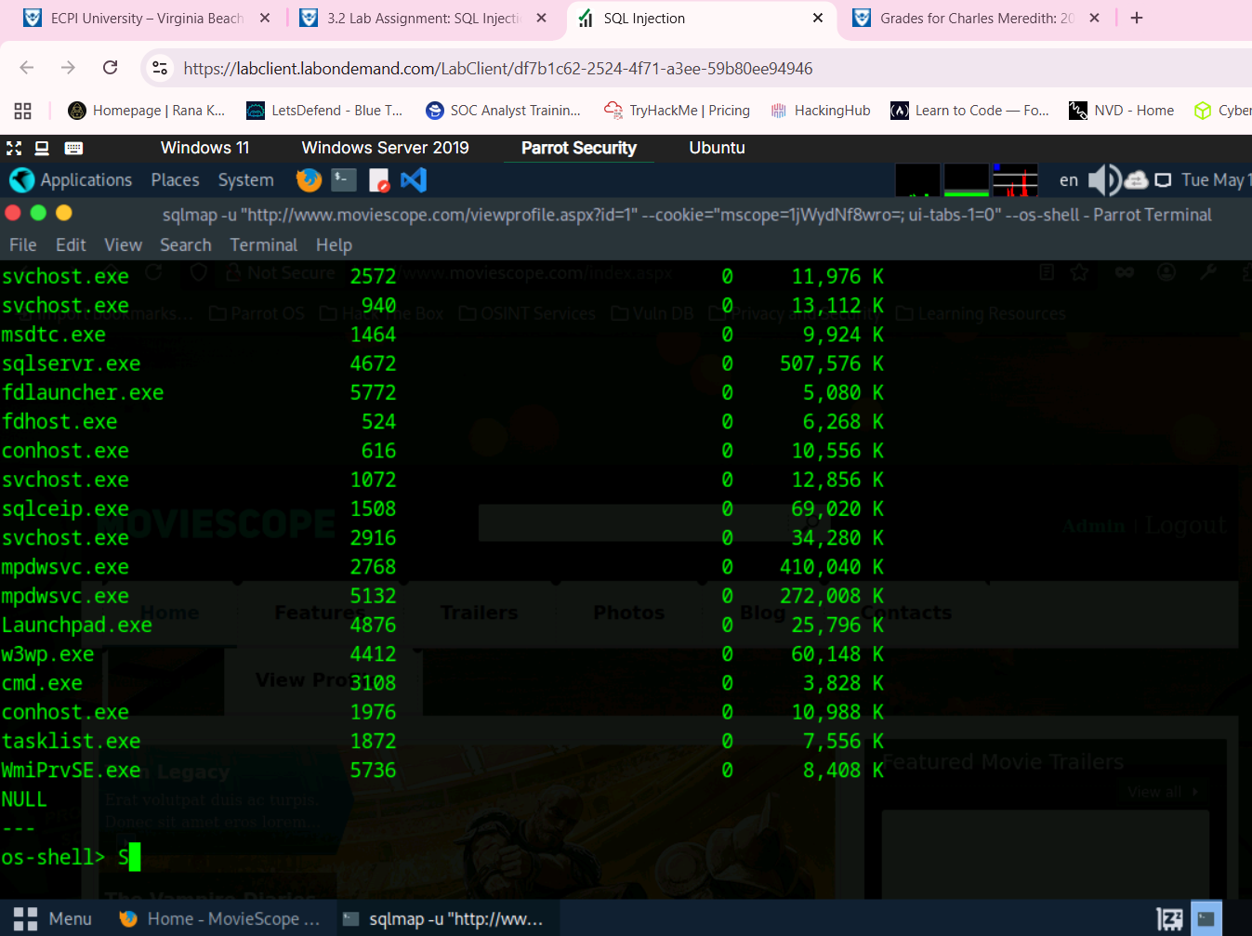
- Lab 2 – Detect SQL injection vulnerabilities using various SQL injection Detection Tools
  - Task 1 - Detect SQL injection vulnerabilities using OWASP ZAP
    - Screenshot step 10
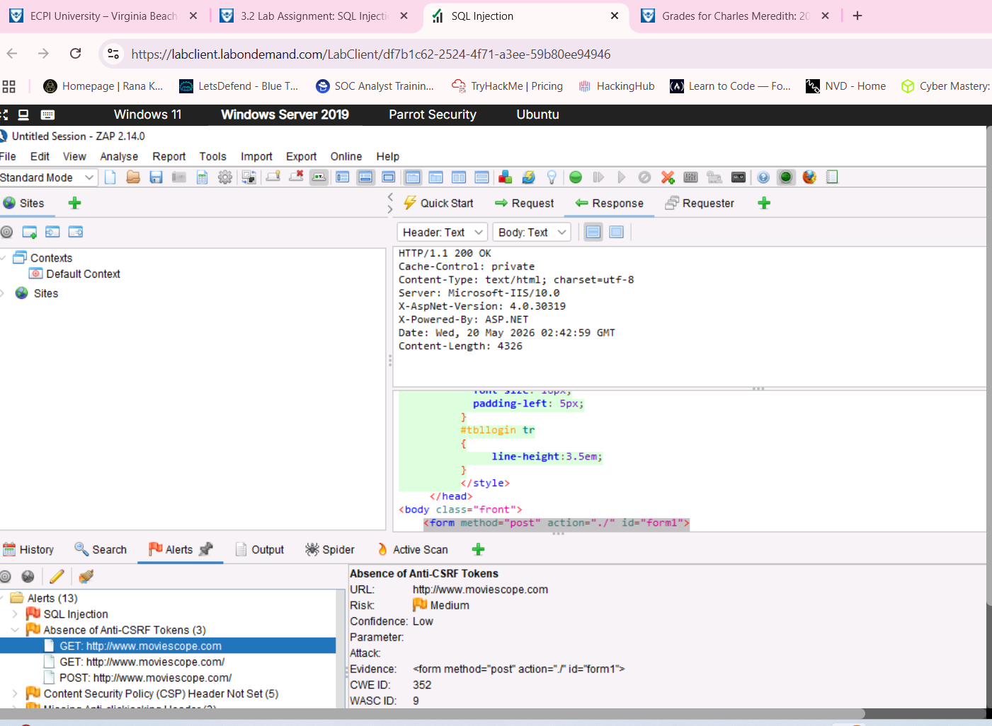
- Lab 3 – Perform SQL Injection using AI
  - Task 1 – Perform SQL Injection using Shell-GPT
    - Screenshot step 12
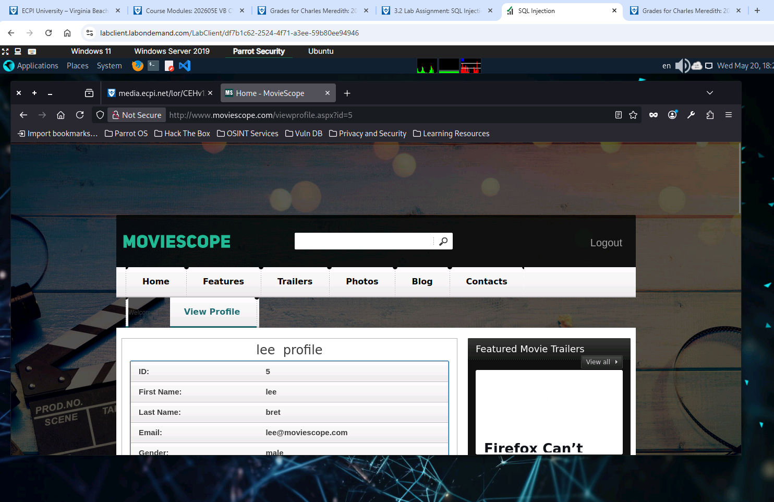
Complete the following lab tasks in the Hacking Wireless Networks iLab Module:

- Lab 1 - Perform Wireless Traffic Analysis
  - Task 1 - Wi-Fi Packet Analysis using Wireshark
    - Screenshot step 6
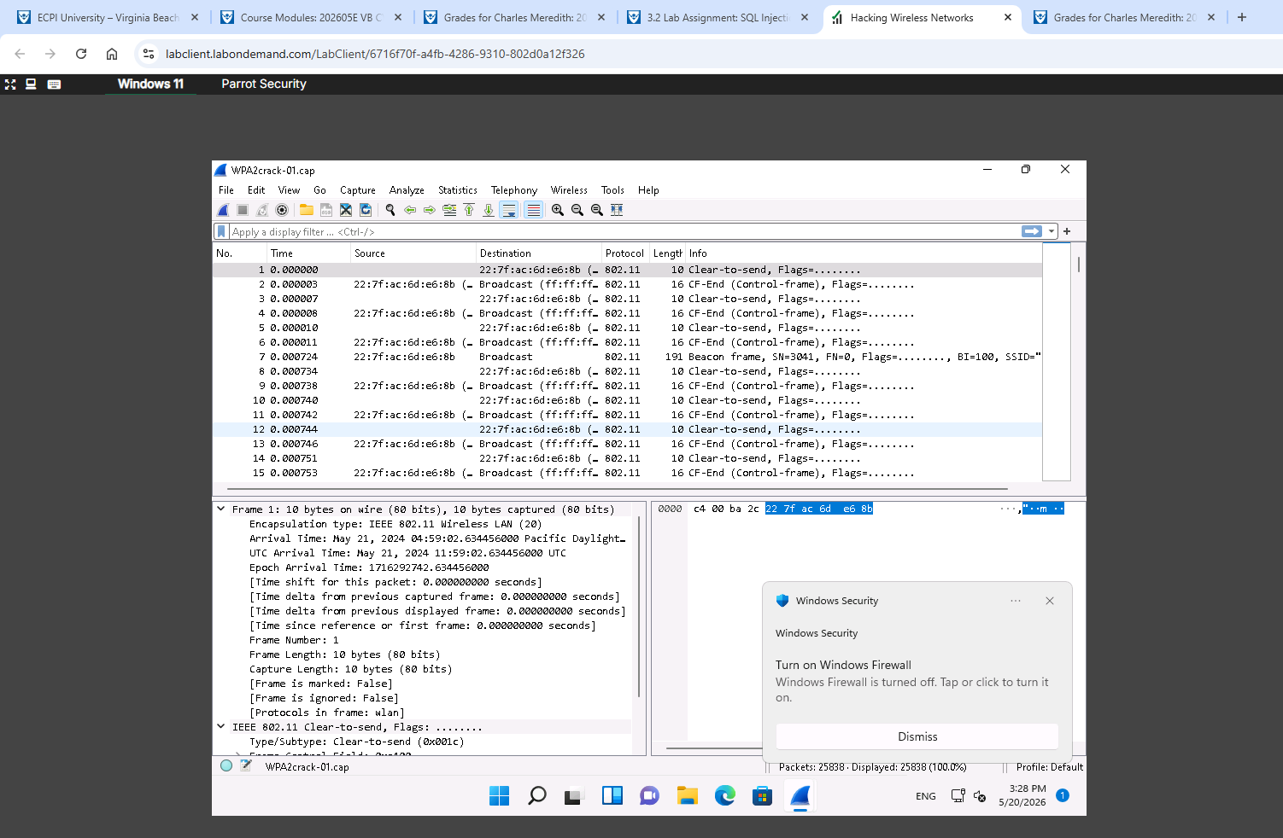
- Lab 2 - Perform Wireless Attacks
  - Task 2 - Crack a WPA2 network using Air crack-ng
    - Screenshot step 7
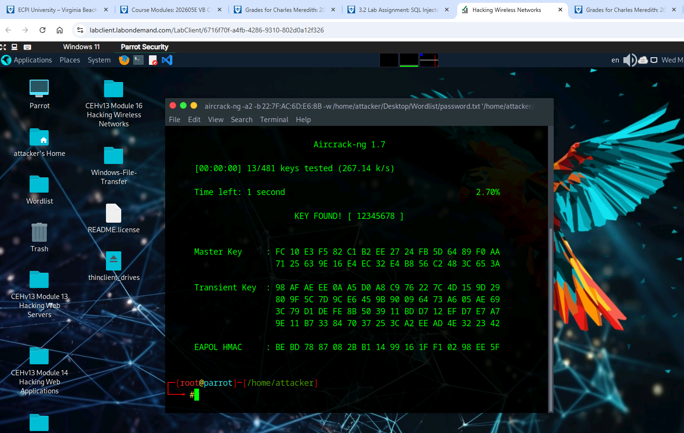

Summary
Write a few paragraphs summarizing the key skills you have acquired during this lab.

In these two labs we ascertained many skills. One of the first tasks performed was SQL injections using SQL map. The Second task was to detect SQL injection attack vectors using OWASP Zap which is an integrated penetration testing tool for finding vulnerabilities in web applications. And for the final task in the first lab, we aggregated all previous techniques and refined them using Shell-GPT.
In the second lab we used two types of wireless networking hacking tools. The first being Wireshark to analyze Wi-Fi-packet sent over network. In the lab we were asked to show the frequency range of said attack, and it was 803.11. For the second lab we cracked a WPA2 connection using Air crack-ng. We didn’t have the means to set up an actual wireless network to hack so we ended up just using a file but all the same the information about the passwords was extracted.

Review Questions
Answer the following questions.
1. An attacker has no error messages from the system with which to work, but rather simply sends a malicious SQL query to the database. This is an example of Blind/Inferential SQL Injection.
2. An attacker deletes specific information, the log, or audit information in a database. This is an example of Compromised Availability of Data.
3. OWASP ZAP is an integrated penetration testing tool for finding vulnerabilities in Web Applications.
4. Command generated by SQL Map may vary depending on the prompt used and the tools available on the
machine.
5. All hardware Aps can interact with other hardware access points is an example of LAN-to-LAN Wireless Network.
6. Wireshark is a network protocol sniffer and analyzer.
7. For this attack, the attacker makes the victim unavailable to other wireless devices by destroying the
connectivity between the access point and client: Deauthentication Attack.

